**A brief manual for running HAMS**

Yingyi Liu

1. Prepare the BEM mesh for the marine structure that the user wants to compute for. The mesh can be in an arbitrary format but will need a mesh converter to transform it to the HAMS mesh format. A good way is to use Rhinoceros to export the hydrodynamic CAD model to the *.gdf format of WAMIT. Then use the built-in tool WAMIT_MeshTran.exe to convert the *.gdf mesh to the HAMS mesh format just by clicking RunWAMIT_MeshTran.bat, and then input manual-ly the path and filename of the *.gdf file in the command line, or simply drag the *.gdf file to the command line. Do remember that the *.gdf file should better include both of the waterplane mesh and the submerged body mesh. The tool can automatically dispart the two meshes into the separate WaterplaneMesh.pnl and HullMesh.pnl files. Note that at the present stage, only the Windows version of the WAMIT_MeshTran program is available. Please wait for some while for the Linux version.

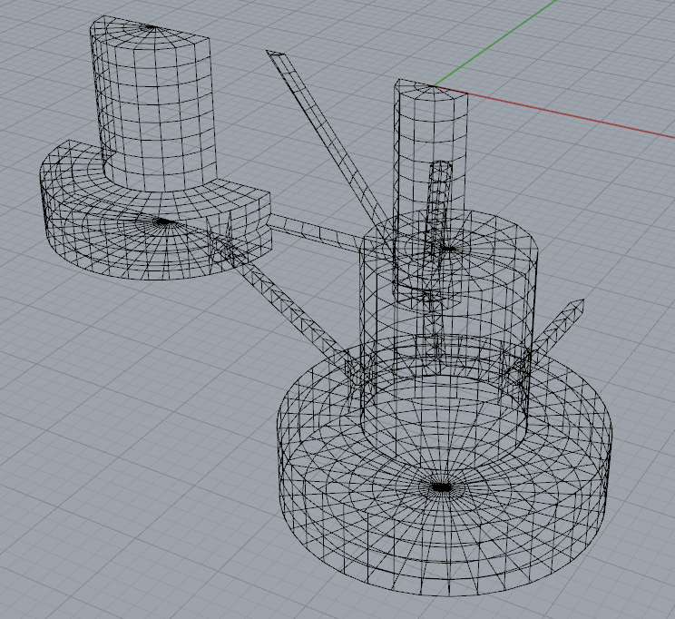

Fig.1 Body mesh and waterplane mesh in Rhinoceros

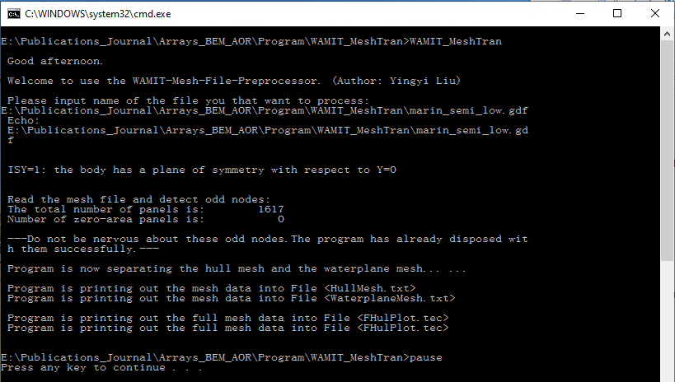

Fig.2 Command line of RunWAMIT_MeshTran.bat

2. Copy the WaterplaneMesh.pnl and HullMesh.pnl files to the Input Folder of HAMS. Make appropriate settings in the ControlFile.in file. There are several places that need attention:

1) Number_of_frequencies: following the WAMIT tradition, when a positive value is input, the next line right after this line should read a set a discrete wave frequencies (or wave periods, or wave numbers or wave lengths), see the “Moonpool” example in the CertTest Folder; when a negative value is input, the next two lines should read separately Minimum_frequency_Wmin (the minimum wave frequency, or wave period, or wave number or wave length) and Frequency_step, see the “Cylinder” example in the CertTest Folder.

2) Number_of_headings: following the similar WAMIT tradition as Number_of_frequencies.

3) Number_of_field_points: this is to specify how many field points the users want to output the field pressure or elevation. Right after this line, the coordinates of these field points are expected to be input.

4) If_remove_irr_freq: set 0 if you do not want to remove the irregular frequencies and set 1 if you want to.

3. The information in the file “fort.4” generated by the mesh converter WAMIT_MeshTran.exe can be used for the Hydrostatic.in file. However, the External Damping Matrix and the External Restoring Matrix should be set by the users.

4. After doing all the above, the user can run HAMS simply by clicking RunHAMS.bat. It worth noting that, the results in the WAMIT format can be visualized easily by BEMRosetta or BEMIO, which can be downloaded here:

<https://github.com/izabala123/BEMRosetta>

<https://wec-sim.github.io/bemio/>